Purpose
Content is the meat of any Social Media plan, it is devoured by potential customers as resources or seen as entertainment spreading awareness. As we learned in Chapters 10 & 11 of our textbook, content is much more than just simple social media posts. It is the resources that are LINKED TO from social media posts. Resources such as articles, news releases, white papers, webinars and ebooks all draw new audience members in by putting your brand on channels they frequent. Content Marketing is the BEST billboard for a brand. This is why audience and voice definition are such important first steps. Now that you know who your audience is, where they like to spend their time, and how they talk, you can create the content that they want to see/hear, in the voice they understand, and place it where they want to find it in their daily life.
On page 194 of our textbook, figure 11.1, the authors published a picture of a content marketing sales funnel as drawn by Kristin Jones (Jones PR) in 2015. Jones has since updated that funnel in her article "5 Best Practices for Lead Nurturing Workflows (Links to an external site.)" (see below). The funnel is now written with the same naming criteria that you will recognize from our earlier exercises in social media ad management. It visually maps out what type of content is used for each stage of the funnel.

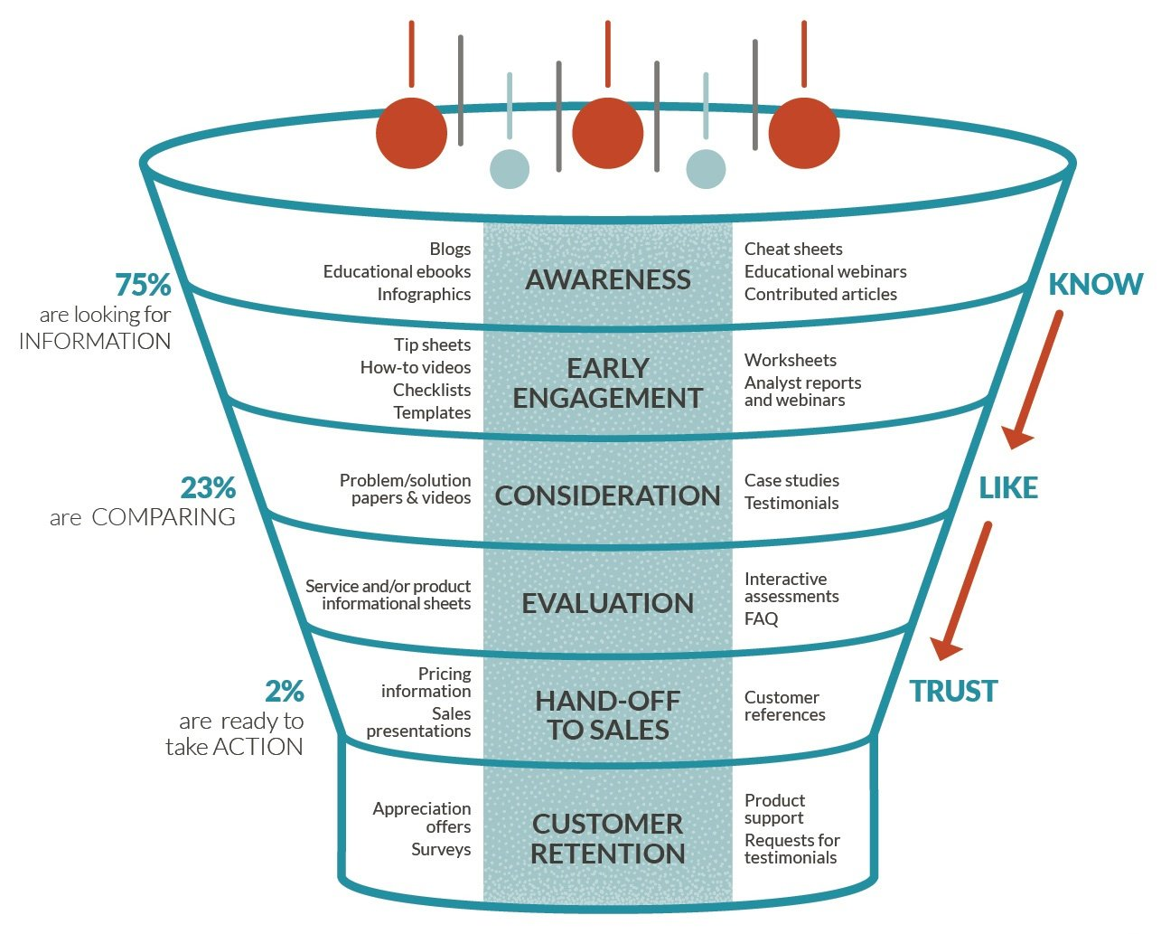

Instructions
There are TWO parts to this assignment.
Part 1:
Using THE SAME company that you used for your first two assignments – USE COCA-COLA AS THE COMPANY - perform brand social media listening in the channels detailed in Chapters 10 and 11 in order to find your company's created resources.
Identify TWO content resource pieces from TWO DIFFERENT SOURCES. (Remember, a social post alone is not the type of content resource we are looking for, we are looking for the content resource a social post could reference by linking to)
You should be looking in places like:
- LinkedIn
- Reddit
- Q&A sites (ex: Quora)
- News aggregators and content creators (ex: Buzzfeed)
Note: YouTube video content is NOT an acceptable form of content for this Assignment. We are focusing only on the types of content mentioned in the platforms analyzed in Chapters 10 and 11. If you use a video you must show where the video lives in other venues than YouTube and how it did on those specific platforms.
List for each piece of content:
- Source where the content was found plus the URL of the content itself.
- Using the names of content types listed to the left and right of the funnel level names in Jones's diagram (ex: blog, infographic, webinar, case studies, etc.), identify what type the content is, and what level of the funnel it relates to.
- Give a short analysis as to whether you think the piece of content achieved its goal and why.
IF the company (COCA-COLA) you have chosen has created content, but has not placed it out on any of the platforms mentioned (for example, it lives on their website alone) then identify where you think it should be placed and why you think that placement will achieve the content's goal.
Part 2:
After identifying what types of content work as resources for your selected company. Create a resource that you think will be a valuable piece of content for consumers and help market your company (COCA-COLA) , and state where it will be placed (this can be more than one platform if wanted). This can be any of the types of content listed in Jones's diagram BUT make sure it something that you have confirmed works well for your company.
For example, if you found that industry articles written or sponsored by the brand and then posted via LinkedIn by their employees are gaining a lot of attention, then create a short industry article for the brand with the intention of it eventually being used in LinkedIn strategy. Or, if you found that the brand gained a lot of attention like Friskies did with "Dear Kitten" in the content Buzzfeed created for them (as explained on page 180 in our textbook), create a storyboard for a video (or an actual video) that matches the style of Buzzfeed.
Ebooks, surveys, white papers, infographics, webinars, editorials/blogs, listicles, tip-sheets, etc.... all are welcome types of content to create as long as you have verified that they work for your company.
If the company you have chosen has not yet created any resources then please send me a message by WEDNESDAY of this week, and we will identify a content rich "sister company" together that you can use to perform this assignment. The "sister company" must be approved by me prior to use.

Grading Criteria
Acceptable file formats: PDF (including downloaded Google Slides or Docs), Word Document, Powerpoint.
Assignments will be graded on how thoroughly they meet the following criteria:
Content
- Addresses the topic or question and uses channels mentioned in the textbook
- Accurately presents the target company chosen - and uses the SAME company as assignment 1 and 2
- Provides sufficient evidence to support the content created
- Content created is well developed and has a clear goal for the company.
Structure
- Includes all listed elements
- Clearly organized
Style
- Is visually appealing (photography and colored layout is appreciated)
- Is free of misspellings
- Is free of grammatical mistakes

